Software Requirements
Specification

A Mobile Application for Facility Management

Team
[YallaFix]

Members
[Nadeen Elkhalifa] | [13004534] (Team Leader)
[Mariam Ashraf] | [13006964]
[Malak Gharib] | [13007525]
[Nour Samir] | [13006170]
[Ganna Hamza] | [13003823]
[Abdelrahman Elkhatib] | [13002667]

Tutorial Details
[Tutorial 4] | [Hassan Usama]

- Introduction
YallaFix is a mobile-based Facility Complaints Hub designed to enable members of the GIU community to report infrastructure, maintenance, sustainability, cleanliness, and safety-related issues on campus. The system provides an easy and structured method for submitting complaints by uploading a photo, adding a description, and specifying the issue location. Facility Management personnel can view complaints, assign workers, and track their status until resolution. The application enhances communication between community members and the Facility Management team, ensuring faster issue resolution and improved campus conditions.

1.1 Product Vision & Scope
The vision of YallaFix is to create an interactive, transparent, and efficient platform for handling facility-related complaints at GIU. The system aims to reduce response times, improve coordination between users and Facility Management, and promote community engagement through social features such as confirmations, comments, and notifications. The scope of the system includes reporting and managing physical campus issues only, such as maintenance, cleanliness, sustainability, and safety hazards. The system does not handle academic, administrative, or personal complaints.

1.2 Definitions and Acronyms
- SRS: Software Requirements Specification
- RBAC: Role-Based Access Control
- Ticket/Complaint: A digital record representing a facility-related issue
- Reporter: GIU community member submitting a complaint
- Manager: Facility Management administrator responsible for handling complaints
- Worker: Technician assigned to resolve complaints
- SLA: Service Level Agreement

- Functional Requirements
Describes what the system should do, first in the form of user stories then as a list of functional requirements for each user/role. A UML use-case diagrams should then be included to link specific features and requirements.
2.1 User Stories
Reporter Story: A student notices an overflowing trash can in a restroom. She opens YallaFix, checks for similar complaints, confirms it if it exists or submits a new complaint by uploading a photo, selecting the location, and writing a description. She receives notifications when the status changes.
Manager Story: A Facility Manager logs into the system, views submitted complaints, assigns a worker, updates the complaint status, and monitors progress through the dashboard.
Worker Story: A technician receives a notification about an assigned complaint, views the details, resolves the issue, uploads proof of completion, and updates the task status.

User 1: Community Member (Reporter)
FR-01: The system shall allow users to create a new complaint.
FR-02: The system shall allow users to upload an image with the complaint.
FR-03: The system shall allow users to select the issue location.
FR-04: The system shall allow users to categorize the complaint.
FR-05: The system shall allow users to confirm existing complaints.
FR-06: The system shall allow users to comment on complaints.
FR-07: The system shall notify users when complaint status changes.

User 2: Manager (Facility Admin)
FR-08: The system shall allow managers to view all complaints.
FR-09: The system shall allow managers to assign workers.
FR-10: The system shall allow managers to update complaint status.
FR-11: The system shall allow managers to merge duplicate complaints.
FR-12: The system shall allow managers to post official updates.

User 3: Worker
FR-13: The system shall notify workers when assigned a complaint.
FR-14: The system shall allow workers to view assigned tasks.
FR-15: The system shall allow workers to upload proof of completion.
FR-16: The system shall allow workers to update task progress.

User 4: System admin
FR-17: (Manage Users)
Admin can add/edit/deactivate users.
FR-18: (Assign Roles)
Admin chooses if a user is Manager / Worker
FR-19: (Reset Credentials)
Admin can reset passwords if someone can’t log in.
FR-20: (Manage Categories)
Admin can add/edit categories like “Cleanliness”, “Safety”, etc.
FR-21: (Manage Locations)
Admin can add/edit campus locations (Building A, Lab 203, etc.) so reporters / students pick from a list.
FR-22: (View System Activity)
Admin can view logs like “Ticket created”, “Status changed”, “Worker assigned”.

2.2 UML Use-case Diagram
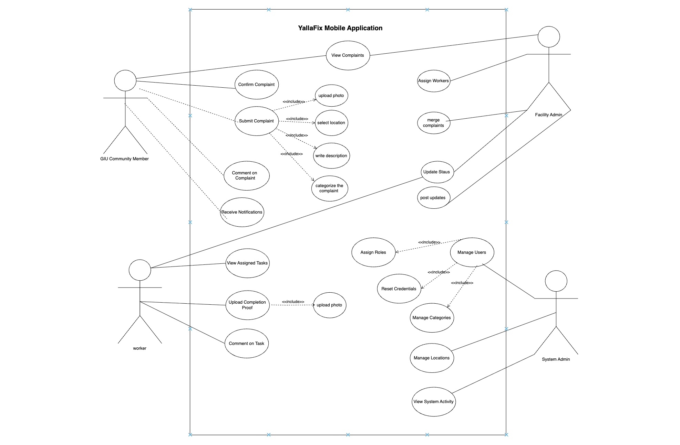

- Non-functional Requirements
- Response Time: Page load times under three seconds.
- Concurrent Users: Support for at least 500 simultaneous users.
- API Security: Rate limiting and input validation.
- Backup & Recovery: Automated daily backups with disaster recovery plan.
- Usability: Intuitive UI allowing complaint submission in under one minute.
- Reliability: Robust handling of image uploads under unstable network conditions.

- Constraints
- Mobile application must be developed using React Native with Expo.
- Backend must be developed using Node.js with RESTful APIs.
- Database must use PostgreSQL.
- Cloud-based image storage must be implemented.
- System must strictly handle facility-related complaints only.

- Entity Relation Diagram
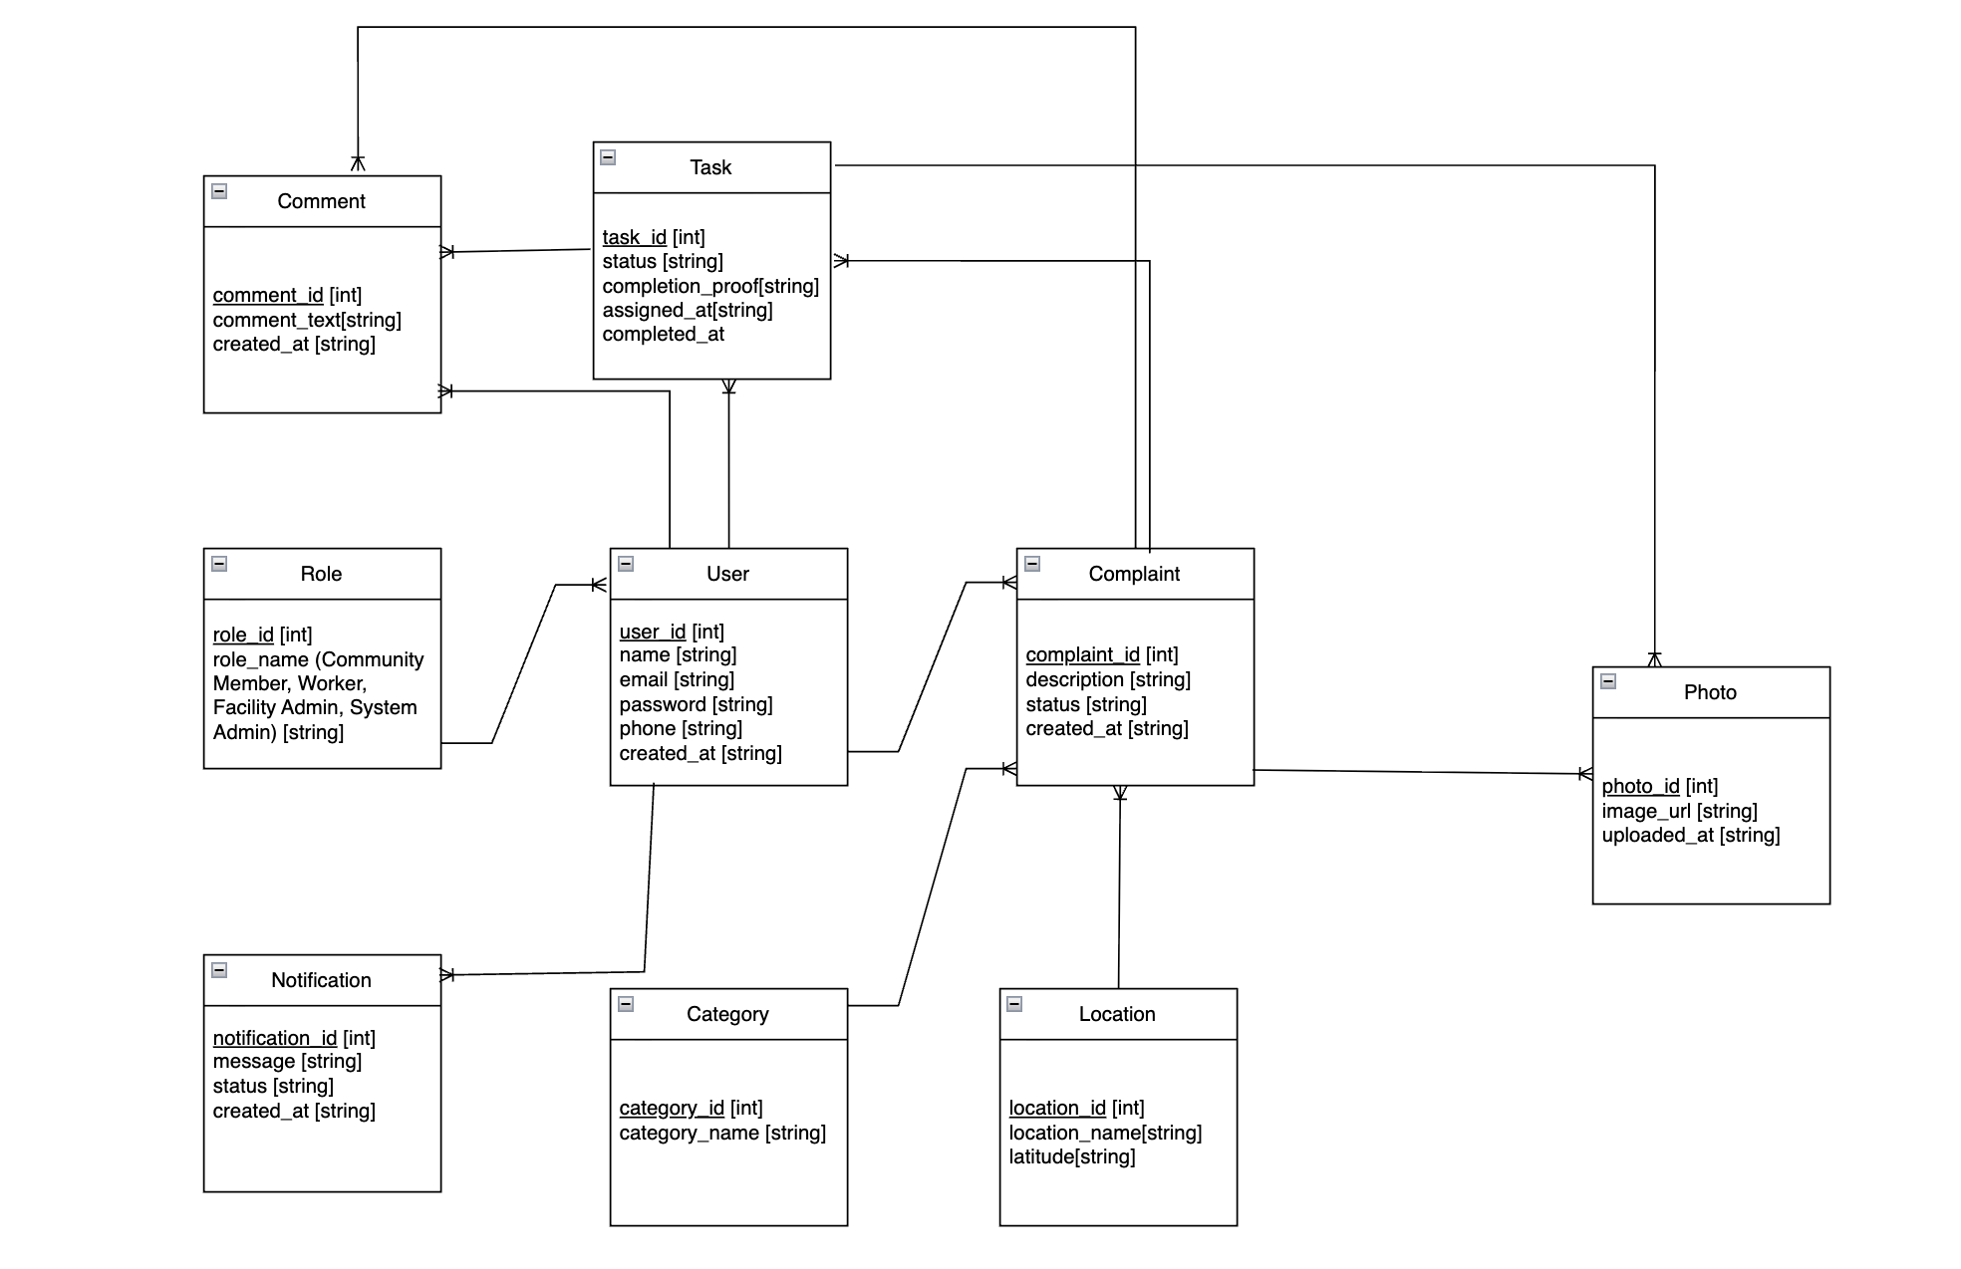

- Technology Stack
- Mobile Application: React Native (Expo).
- Backend: Node.js with Express and RESTful APIs.
- Database: PostgreSQL.
- Authentication: JWT-based authentication.
- Image Storage: Cloud storage service (e.g., Firebase or Cloudinary).

- Future Scope of the Project
- Heatmap visualization of frequent issue locations.
- SLA-based automatic prioritization system.
- Analytics dashboard for performance tracking.
- Gamification features for active contributors.
- AI-based duplicate detection system.

